User Guide:
Salesforce End of Tenancy

Version History
Version | Description of Change | Author | Date
0.1 | First Draft | Nikki Papenfus | 12/12/2023
0.2 | Axis & Grainger Trust Changes | Nikki Papenfus | 29/04/2024

Table of Contents
1. Overview 3
2. How to Create an EOT 7
2.1 Creating an EOT for Grainger Trust Units 8
3. The EOT at a Glance 9
3.1 Key EOT Details 10
4. End of Tenancy Tasks 11
4.1 Where Do I Find My Tasks? 11
4.2 The Task at a Glance 12
4.3 Task Statuses 13
4.4 Starting a Task 13
4.5 Completing a Task 14
(a) Axis Voids 15
4.6 Setting Tasks to N/A 16
4.7 Reopening a Closed Task 16
4.8 Expected Delays 17
4.9 Overdue Tasks & Task Duration 19
5. Cancel or Close an End of Tenancy 20
6. Reports & Dashboards 21
6.1 Onsite Property Management Reports 21
6.2 Cost of Void Report 21
6.3 Asset Management Reports 22
7. End of Tenancy Owners 23
7.1 Finding My End of Tenancies 23
7.2 End of Tenancies at Risk 23
7.3 Approving Requests to Cancel or Close an End of Tenancy 24

Overview
The End of Tenancy process takes place from the time it is known that a tenant will be vacating a unit until all activities required to wind down the tenancy and make the unit ready for the next tenant are complete. These activities include:
- Notifying the relevant persons that the unit is becoming vacant.
- The pre-vacation inspection (PVI).
- Tenant move out.
- Works to refurbish, refresh or clean the unit.
- Closing down the tenancy & returning the tenant’s deposit.
Note that End of Tenancy does not include move-in or activities related to the following tenancy.
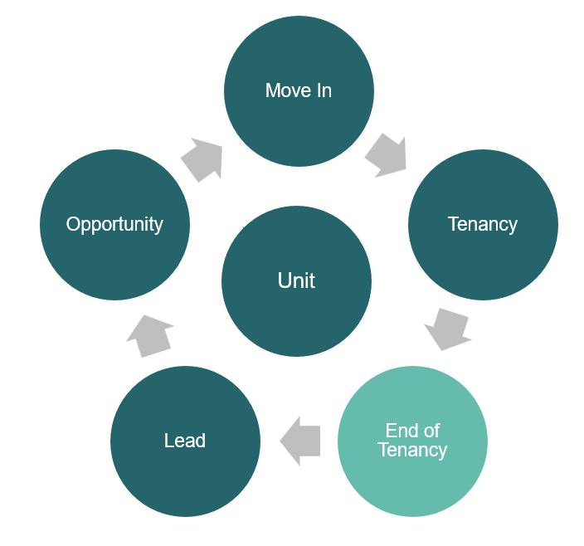
As soon as a tenant provides their notice to quit (NTQ), an End of Tenancy should be created in Salesforce.
- Each End of Tenancy contains a sequence of phases that the process will progress through.
- Each phase contains tasks that must be completed.
- Each task is automatically assigned to a responsible team.
- Thereafter, tasks are assigned to individual person within the team, the task owner, who can monitor the tasks that are ready to be worked on within Salesforce.
When initially created, an estimated timeline is calculated for the End of Tenancy, based on the information available at the time. Each task will have an estimated start date & target end date, and the resultant available date for the unit will be projected.
Any expected delays may also be incorporated into the timeline.
End of Tenancy Phases & Tasks
The following illustrates the sequence of phases and tasks.
- Some tasks will start on the PVI Date or on the Future Vacant Date.
- Other tasks may be dependent on previous, prerequisite tasks being completed.
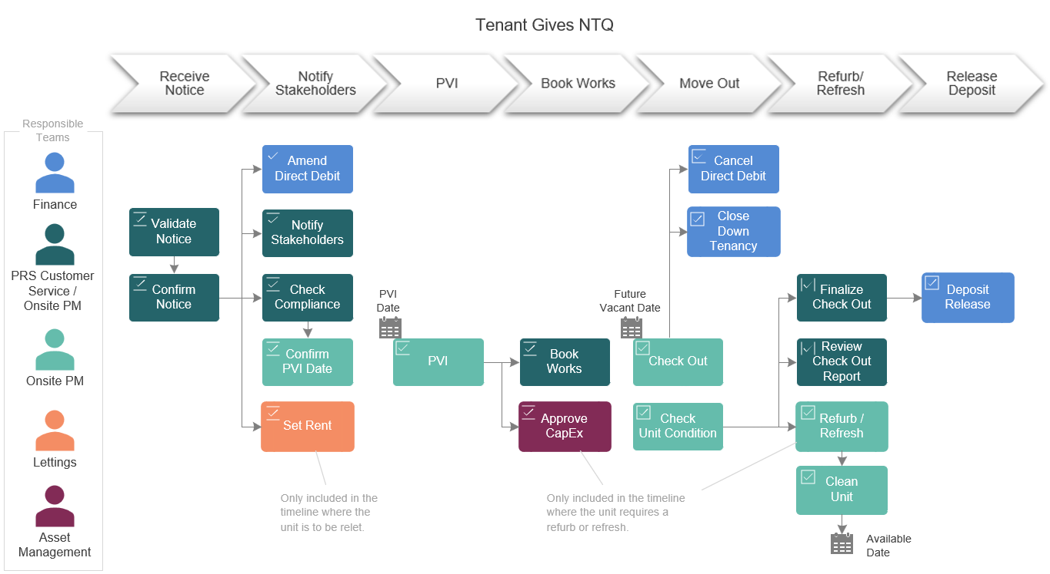

The estimated task dates are automatically updated when:
- The PVI Date and Future Vacant Date are updated and confirmed.
- Prerequiste tasks are completed.
- Any expected delays are captured.

Tasks will be added or removed from the timeline when:
- The unit is flagged to be relet.
- The works type required for the unit (i.e. refurbishment, refresh or clean only) is updated.

A slightly different sequence of tasks is availble for Grainger Trust units.
In this timeline, the task to Check Unit Condition will only take place after all works are complete:
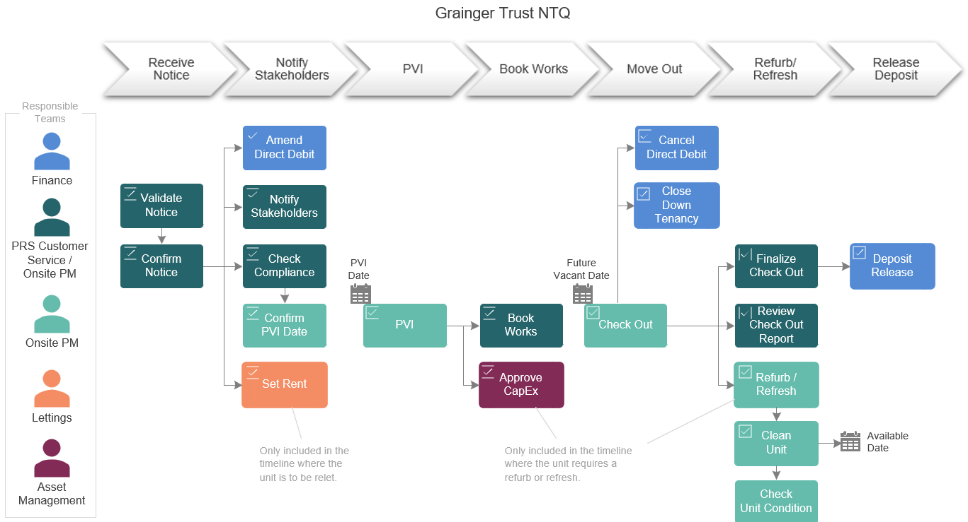

Interaction between End of Tenancy & other Tenancy-Related Objects in Salesforce
The integration between the End of Tenancy and related information in Salesforce is illustrated below:
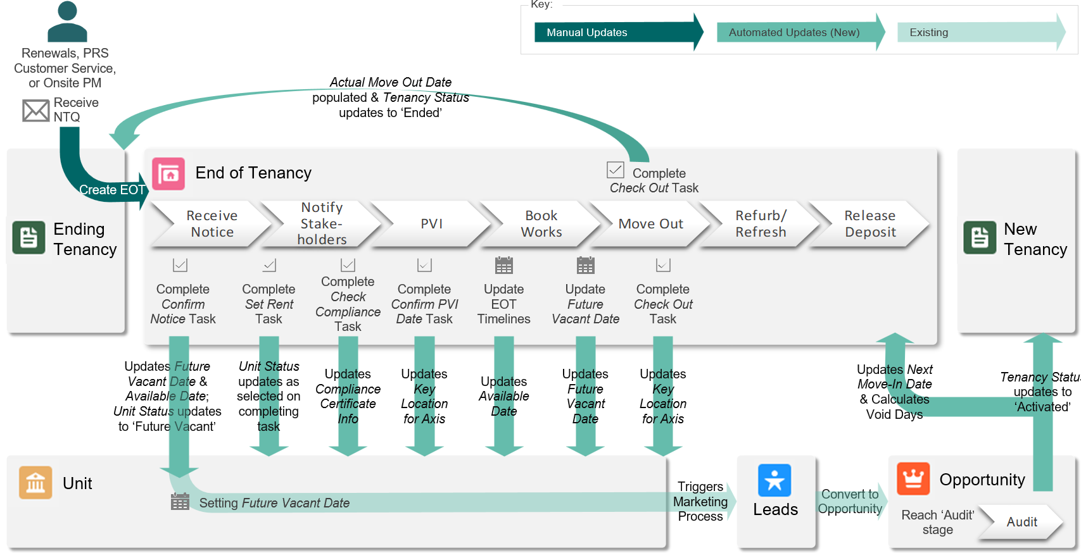
- The following unit details will be automatically updated from the End of Tenancy:
  - The unit’s Future Vacant Date and estimated Available Date will be updated at the end of the Receive Notice phase, i.e. once the notice to quit has been validated and confirmed. Any subsequent changes to the Future Vacant Date or the Available Date in the End of Tenancy will immediately update the unit.
  - The unit status will be updated to ‘Future Vacant’ at the end of the Receive Notice phase, and again to either ‘On the Market Available to View’ or ‘On the Market - No Access’ based on the information entered by Lettings on completing the Set Rent task.
  - Compliance certificate information will be reviewed & updated on completion of the Check Compliance task.
  - Where a unit is under full Axis contract: The key location for Axis voids will be reviewed & updated when completing the Confirm PVI Date task, and again on completing the Check Out task.
- The ending tenancy will be automatically updated on completion of the Check Out task: The Actual Move Out Date will be saved and the Tenancy Status updated to ‘Ended’.
- Once the new tenancy for the unit is confirmed (i.e. the associated opportunity reaches the ‘Audit’ stage), the number of days which the unit stood vacant and the associated void cost can be calculated.

How to Create an EOT
An End of Tenancy is created from the vacating tenant’s Tenancy.
To create a new End of Tenancy, open the Tenancy for the vacating tenant and select ‘Create End of Tenancy’.

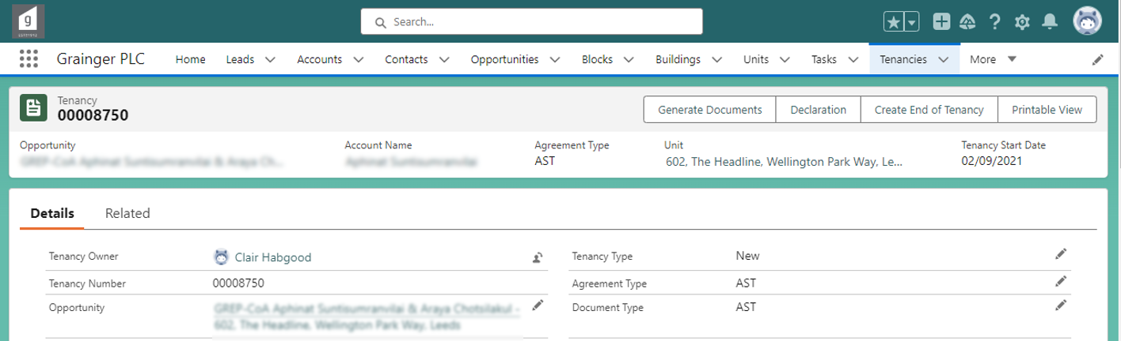
Any existing End of Tenancies can be seen on the Related tab.
If the Future Vacant Date is not known or not confirmed, enter an estimated date; this can be changed later.

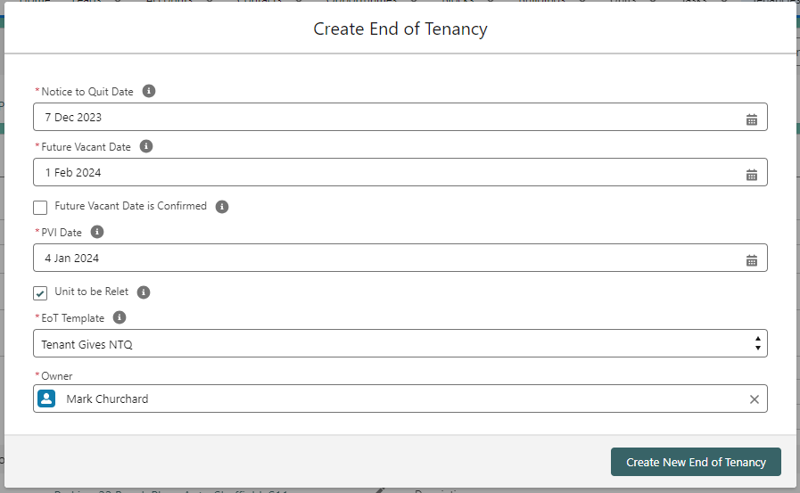
The Unit Manager is responsible for the overall End of Tenancy.
The PVI Date will default to 4 weeks prior to Future Vacant Date but can be changed if required. The PVI Date can also be updated at a later time once the Future Vacant Date is confirmed.


A unit cannot have more than one End of Tenancy in progress at a time.
A summary of all active & complete End of Tenancy’s for a particular unit can be found on the Unit’s Related screen.

Creating an EOT for Grainger Trust Units
Where a Grainger Trust unit does not have any tenancies associated in Salesforce, an End of Tenancy can created directly from the unit screen.
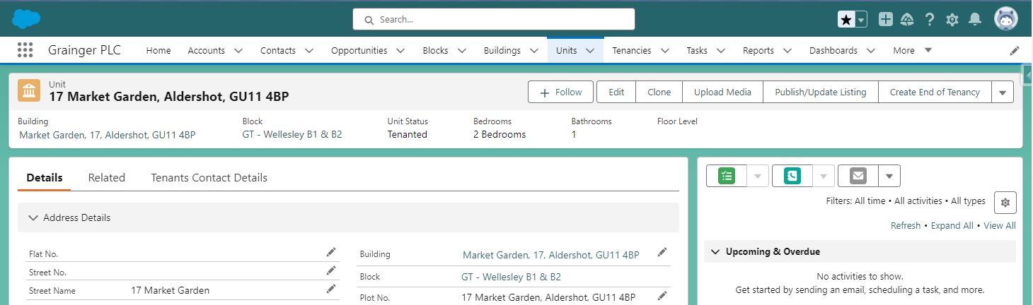
The option to ‘Create End of Tenancy’ will only be available on the Unit screen for Grainger Trust units that do not have any tenancies in Salesforce.
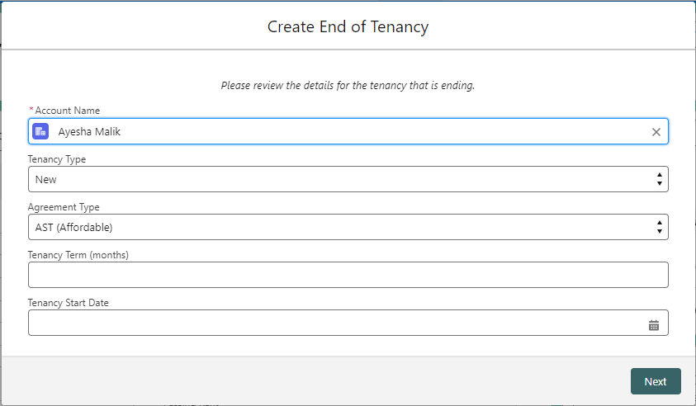
First enter details of the tenancy that is ending. A new tenancy will be automatically created by the system.
Where there is a Closed Won opportunity for the unit, some of the tenancy details will be prepopulated based on the opportunity.
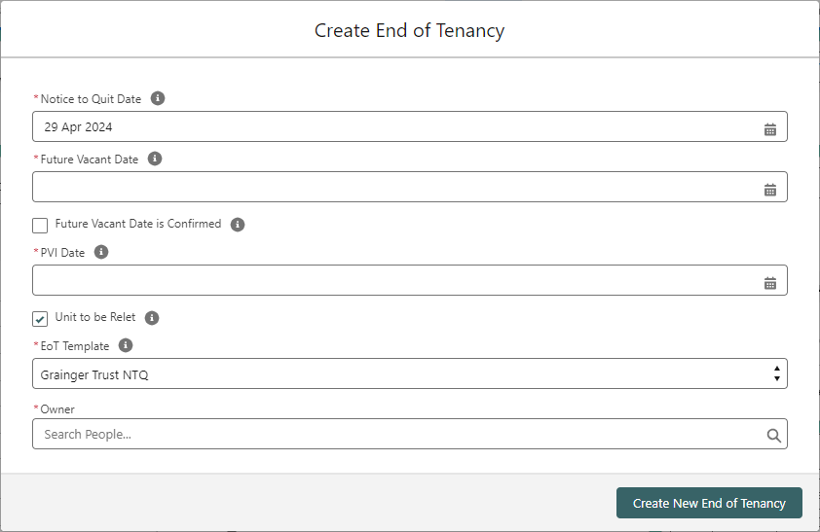
On the next screen, be sure to select ‘Grainger Trust NTQ’ as the EoT Template.
This will create an End of Tenancy with tasks & timelines that have been customized for Grainger Trust units.

The EOT at a Glance
End of Tenancy phases will automatically close once all the tasks within a phase are complete.
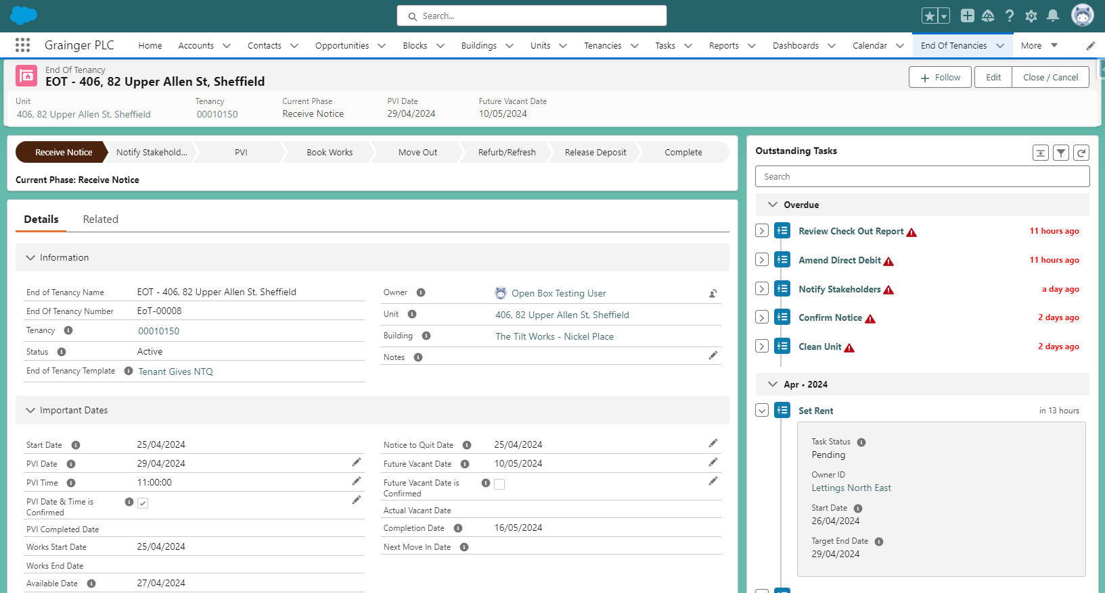
The EOT Owner is responsible for the overall EOT
The End of Tenancy will automatically update to ‘Complete’ once all tasks are complete.
Completion Date: Date on which the EOT process is expected to be complete. Automatically updates as timelines change.

Available Date: Date the unit is expected to be available (i.e. any works are completed & the unit is cleaned). Automatically updates as EOT timelines change.
Task Owner: Person / team responsible for an individual task.
A timeline of all outstanding tasks. Click on a task name to open the task details.
Relevant emails and documents can be attached to the End of Tenancy, these may include:
- Notice to quit & related emails from the tenant.
- Deposit Return Instruction
- Check Out Report
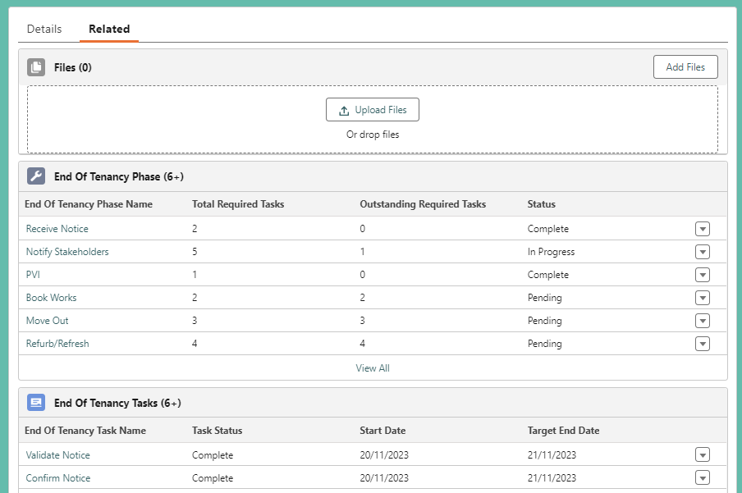
Access the full list of associated tasks, including completed tasks, here.


Key EOT Details
Note that some of the End of Tenancy details will affect timelines and tasks:
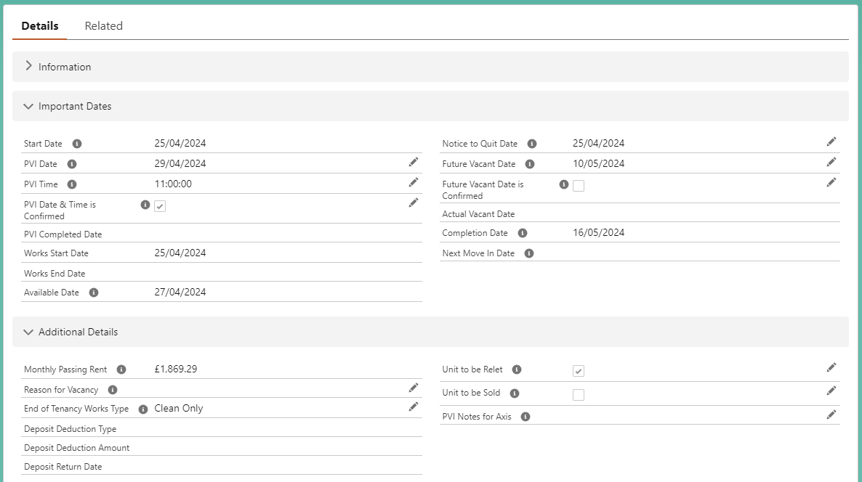
The Approve Capex & Refresh / Refurb tasks only appear in the timeline when the Works Type is set to Refurb or Refresh.
Unit to be Sold determines whether or not Asset Management see this unit on the AM Portfolio Dashboard as confirmed for sale.
The Set Rent task only appears in the timeline for Lettings to complete when Unit to be Relet is ticked.
The PVI task only appears ready to be worked on when PVI Date & Time is Confirmed is ticked. This will be ticked automatically on completing the Confirm PVI Date task.
Updating the Future Vacant Date after the Amend Direct Debit task has been completed, will automatically re-open the task and notify the task owner that the direct debit needs to amended again.
Tasks, such as Check Out, that are due to start on FV Date will only appear ready to be worked on when Future Vacant Date is Confirmed is ticked.

Note that the following End of Tenancy details cannot be entered directly; these will display on the Details screen as the information becomes available:
End of Tenancy Details that are Automatically Calculated
Start Date | Date End of Tenancy was created.
Available Date | Day after the Clean Unit task is due to be completed / was completed.  Updates automatically as the End of Tenancy timelines change.
Completion Date | Date the last End of Tenancy task is due to be completed / was completed.  Updates automatically as the End of Tenancy timelines change.
PVI Completed Date | Date on which the PVI task is completed.
Works Start Date | Date on which the Check Out task is completed.
Deposit Return Date | Date on which the the Deposit Release is completed.
Monthly Passing Rent | Sourced from the ending tenancy’s details in Salesforce.
Next Move In Date | Tenancy Start Date for the next tenancy for the unit.

End of Tenancy Tasks

Where Do I Find My Tasks?
End of Tenancy tasks that ready to be worked on can be found on the Salesforce Home page.
- My EoT Tasks for Today displays all tasks that are assigned to you & ready to be worked on.
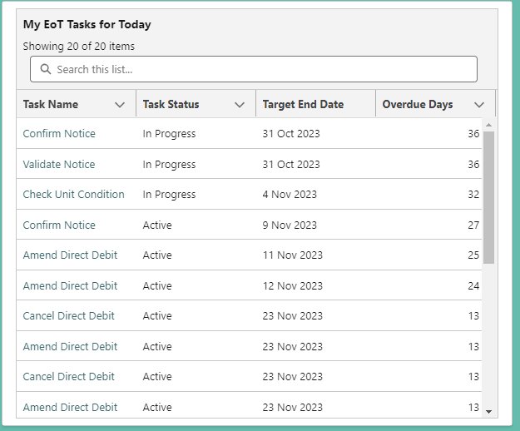
The most urgent tasks are displayed at the top of the list.
- My Team’s Unassigned EoT Tasks for Today displays all tasks for which your team is responsible and are ready to be worked on, but have not yet been assigned to anyone.
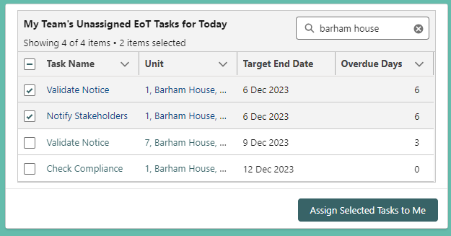
Shortcut to assign one or more tasks to yourself.
Filter by task name or unit.
Add a comma to search for multiple names, e.g.:
“ancoats, headline”.

Task lists for each team can also be found under the End of Tenancy Tasks menu item.
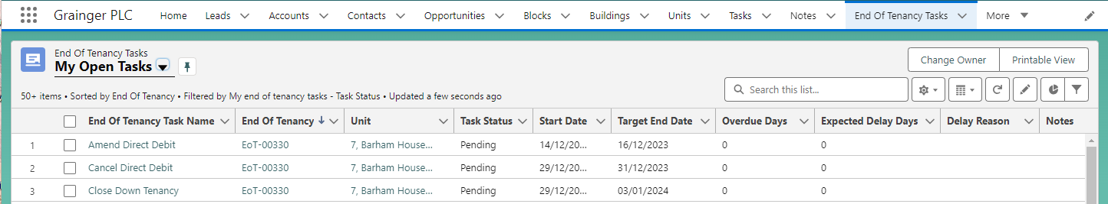

The Task at a Glance
Task Status: Active tasks are ready to be worked on once the start date is reached.
Target End Date:
Date by which the task should be completed.
Start Date: Date when work should begin on the task.

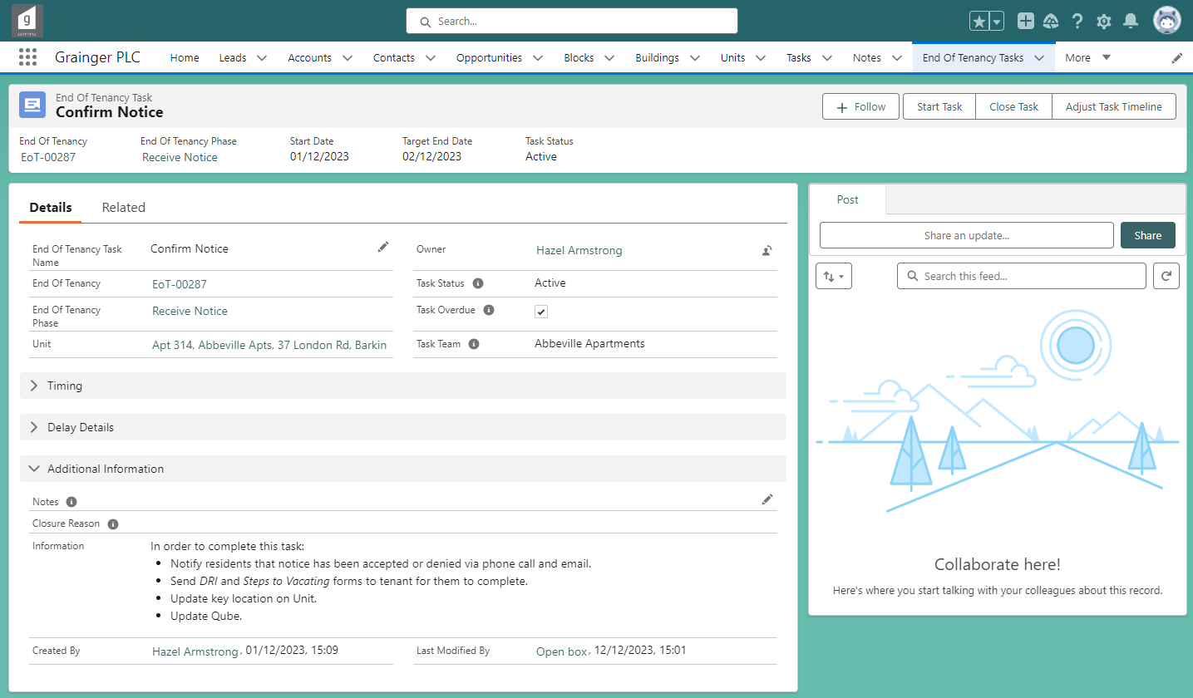
Notes: Capture any relevant notes about task progress; these may appear in reports.
Owner: Person responsible for completing the task.
Tasks are initially assigned to a Task Team and should be allocated to an individual as start date approaches.
Files: Documents & emails can be linked to a task in the Related tab.
Information: Guidance on what needs to be done before the task can be marked as complete.

A task’s Start Date and Target End Date will automatically update as work progresses on the End of Tenancy.
- Where a task is dependent on the Future Vacate Date or PVI Date, the task dates will automatically update when these dates changes.
- Where a task is dependent on other prerequisite tasks being completed, the task dates will automatically update as preceding tasks are completed or where any expected delays are captured.

Task Statuses
Tasks progress through a sequence of statuses:
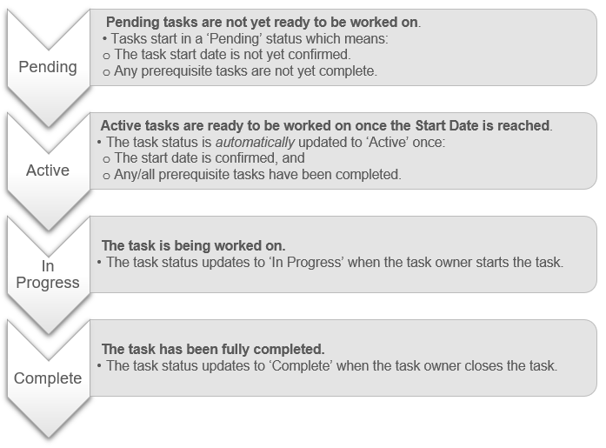
Alternately, where a task is not applicable for a particular End of Tenancy, the task status can be set to ‘N/A’. See Setting Tasks to N/A.

Starting a Task
Select ‘Start Task’
If you have started working on a task, but it is not yet complete:
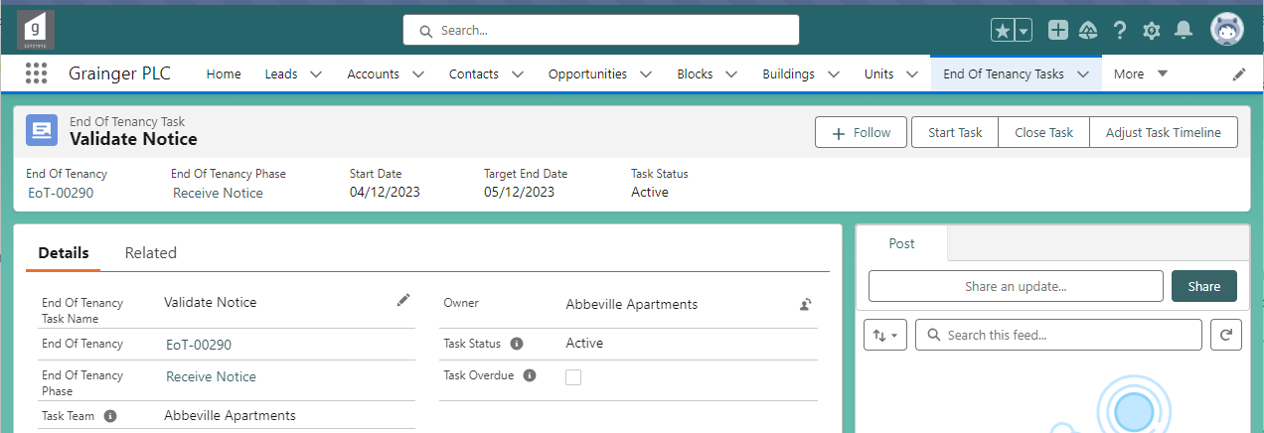
You will be automatically assigned as the task Owner
& the task status will be set to ‘In Progress’.

Completing a Task
Select ‘Close Task’
Once a task is complete:
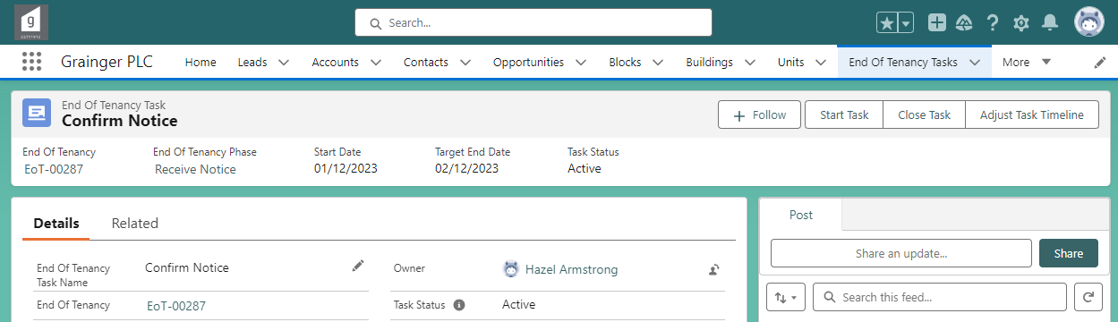
Select ‘Complete’
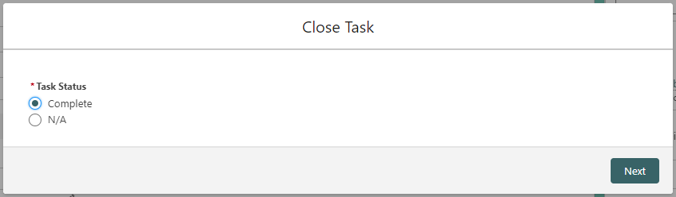
Certain tasks require specific information to be reviewed & updated when closing the task.
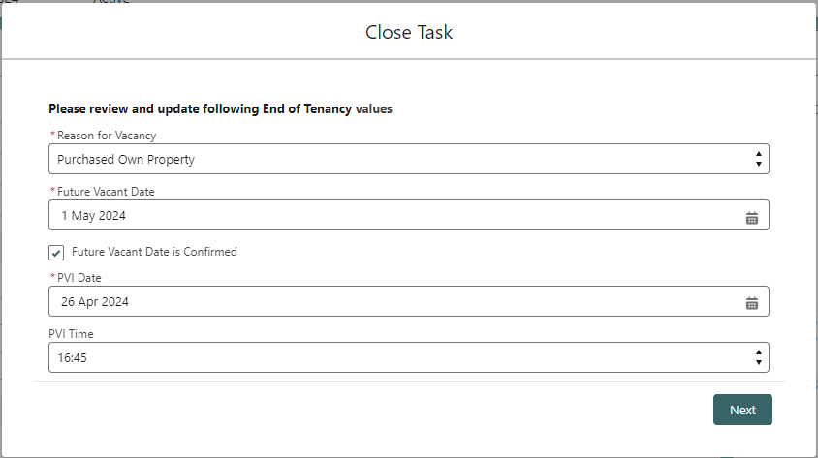
If a task is completed 2 or more days late (i.e. after the Target Due Date), then a reason for the delayed completion will also be required when completing the task.
You don’t need to start a task before completing it; tasks can be set straight to complete.

Axis Voids
Where an estate is under full Axis contract, users will be prompted to provide additional details that will be sent to Axis ahead of the PVI:
- When the Confirm PVI Date task is completed, the user will be required to provide key location details for Axis as well as, optionally, enter PVI-related notes for Axis.
- When the Check Out task is completed, the user will be given the option to update the key location details for Axis.
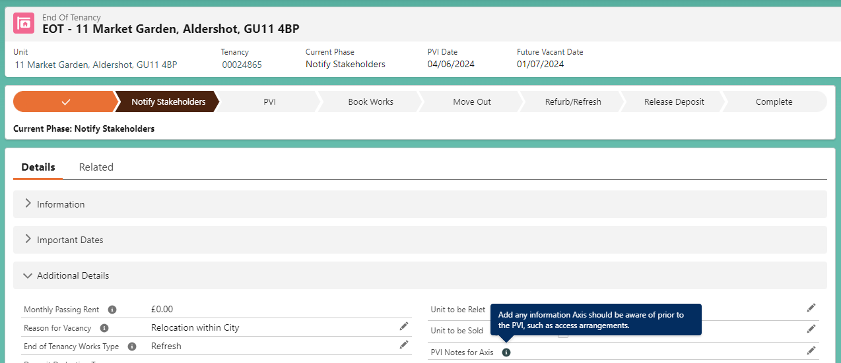
PVI Notes for Axis – This field is only displayed where the estate is under full Axis contract.

Setting Tasks to N/A
Where a task is not relevant for a particular End of Tenancy, the task status can be set to ‘N/A’.
- For example, Approve Capex tasks may be set to ‘N/A’ if the refurb or refresh costs are below the threshold requiring approval.
- Tasks set to ‘N/A’ are not included in the End of Tenancy timeline.
Select ‘Close Task’
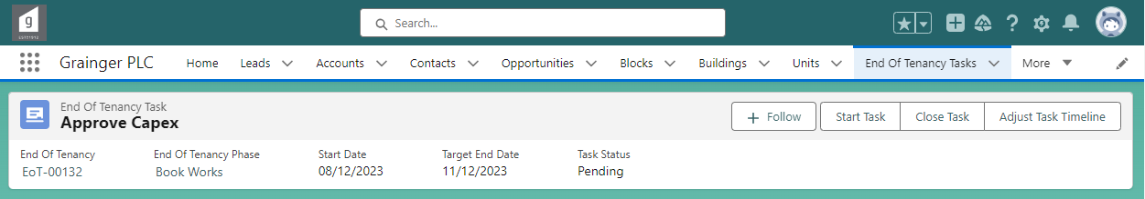
Select ‘N/A’
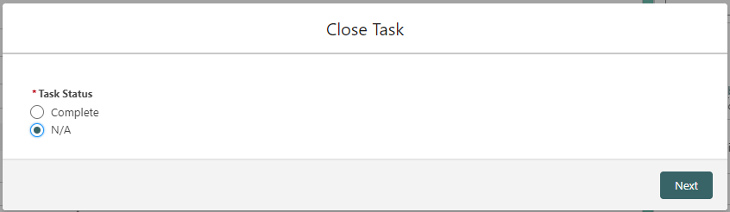

Reopening a Closed Task
Select ‘Open Task’
If a task’s status was set to ‘Complete’ or ‘N/A’ by mistake:
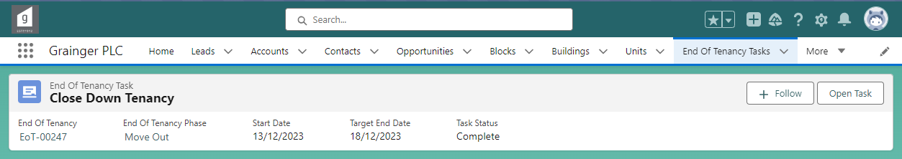
Set the task back to the previous status. See Task Statuses for more information.
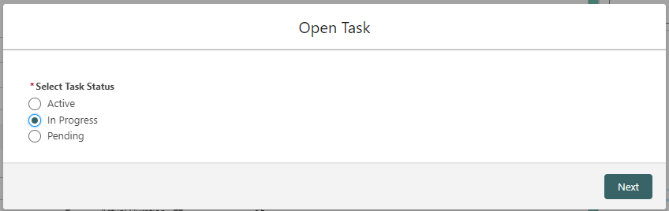

Expected Delays
Where a task is likely to be delayed, the expected delay can be incorporated into the task dates by adjusting the task timeline.
- The End of Tenancy’s Available Date, Completion Date as well as any other tasks that are dependent on the delayed task, will be automatically updated to reflect the delayed timelines.
Select ‘Adjust Task Timeline’
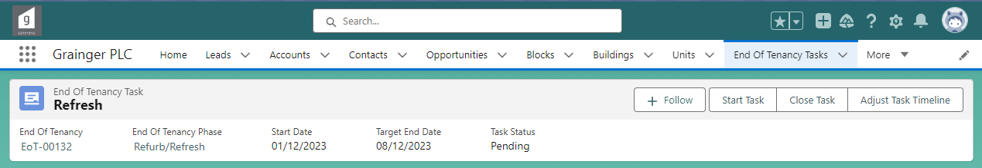
Select ‘Adjust Timeline’
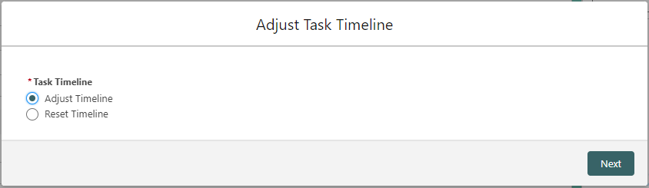
The task duration (i.e. number of days that the task is expected to take to complete) can be updated by selecting either a new Expected Duration or a new Expected End Date.

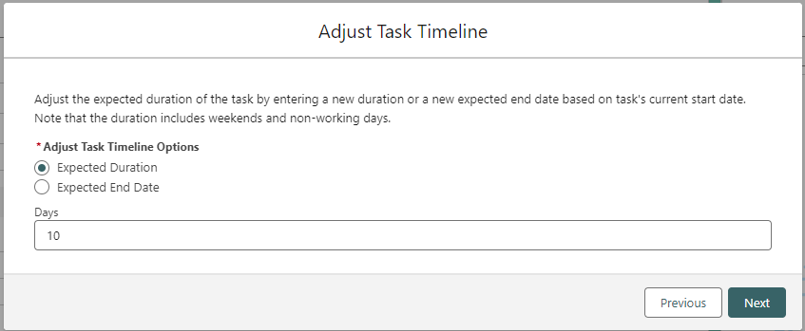
Note duration includes weekends & bank holidays.
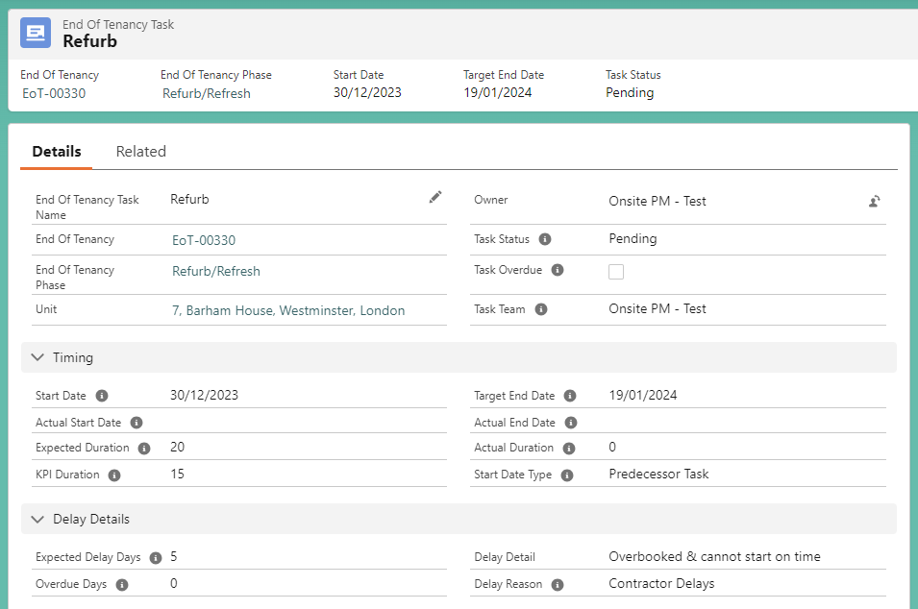
The task’s Expected Duration is updated based on the adjustment entered, and the Target End Date is updated accordingly.
KPI Duration reflects the original task duration before any adjustments were made to the task timeline.
Expected Duration
Expected Delay Days: The number of days by which the task is delayed.
The reason a task is delayed or overdue.

A task’s timeline can also be adjusted to be completed ahead of schedule. No delay reason needs to be entered when shortening a task’s timeline.

To update any of the expected delay information: Select ‘Adjust Task Timeline’ again & follow the above screens again to update the delay information already entered.
Select ‘Adjust Task Timeline’
To remove an expected delay:
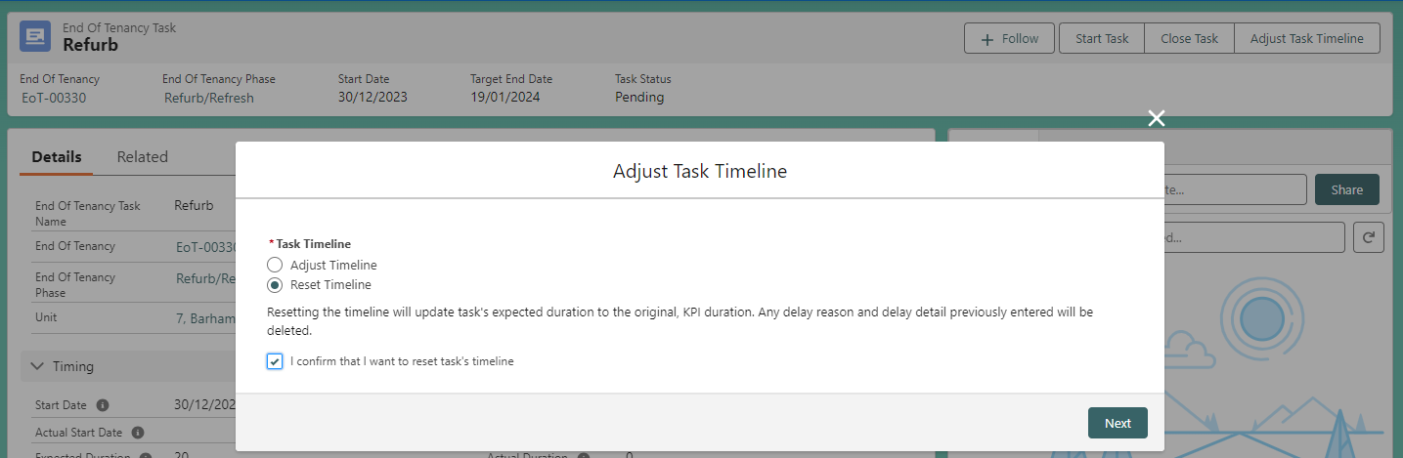
All delay information is removed from the task on selecting ‘Next’.
The task’ expected duration is reset to the original, KPI Duration.
Select ‘Reset Timeline’

Overdue Tasks & Task Duration
Information about task timing & delays is displayed as part of the task details. This is derived from how long the task should have taken, any expected delays, as well as how long the task actually took to complete.
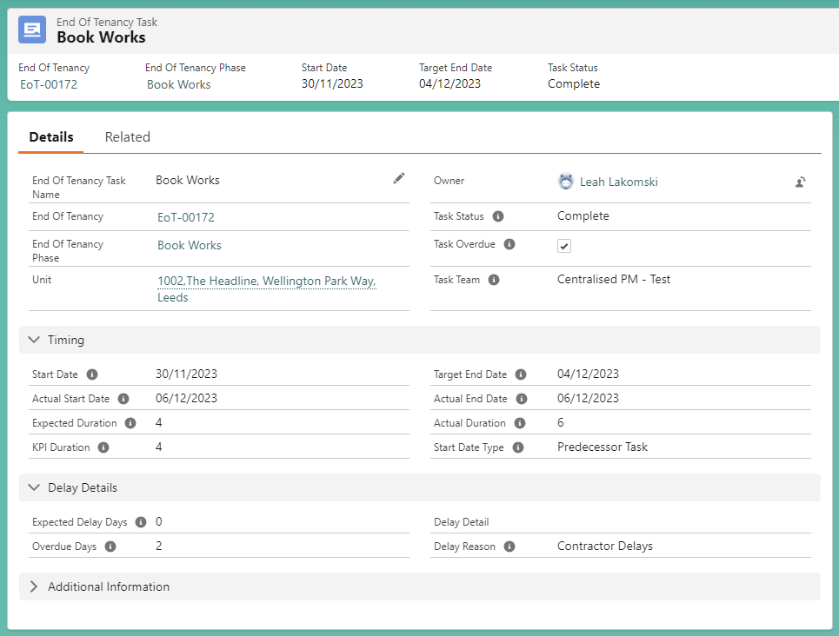
Actual Duration
Actual Duration of a task is the number of days from when the task should have started, to when it was completed.
Number of days this type of task is typically expected to take.
Number of days by which the task is/was overdue.
The reason a task is delayed or overdue.
If a task is not completed by the Target End Date, then it becomes overdue.
Below are some examples of how the task dates and durations relate to each other:
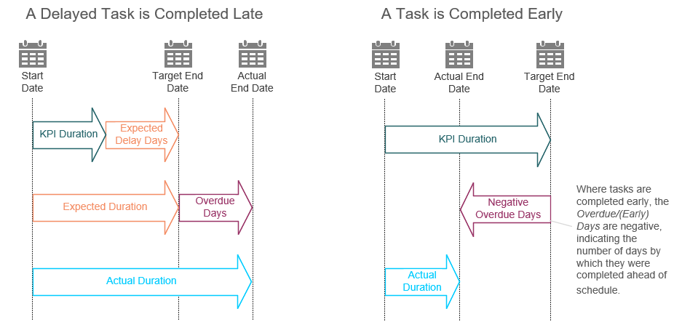

Cancel or Close an End of Tenancy
Once an End of Tenancy has been created, it may be cancelled (for example, where created for the wrong unit) or closed (for example, if the tenant rescinds their notice to quit).
- Once cancelled or closed, the End of Tenancy & associated tasks can no longer be updated or worked on. The remaining tasks will no longer appear in team/user task lists.
Select ‘Close / Cancel’
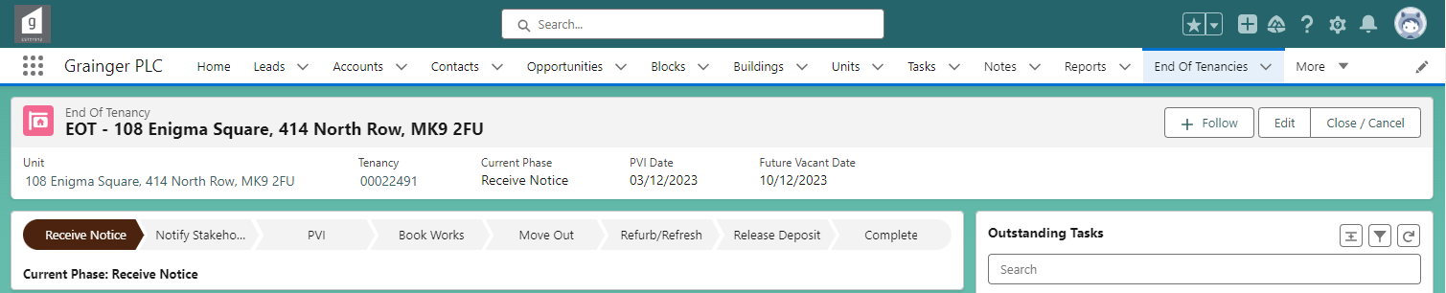
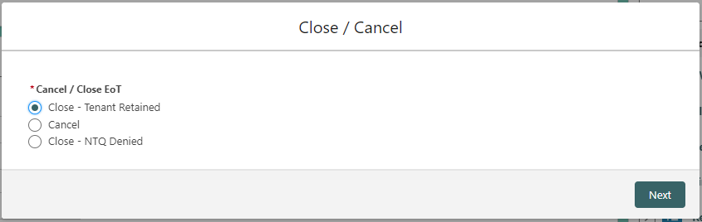
Follow the screen prompts to capture the reason for cancelling or closing the End of Tenancy.

Once the initial Receive Notice phase is complete –
- It is possible that the unit may have already been reserved.
- If anyone other than the End of Tenancy Owner follows the above steps after the intial phase, then the End of Tenancy will not be closed immediately; instead a request to close the End of Tenancy will be submitted to the Owner for approval.
  - See Approving Requests to Cancel or Close an End of Tenancy.
- While the request is pending approval, the End of Tenancy will be updated to a ‘Pending Cancel/Close’ status and users will not be able to update the End of Tenancy or any associated tasks.
- The requestor will be notified when the request is approved or rejected.

Reports & Dashboards
Metrics and reports related to End of Tenancies can be found on the following dashboards:
- PRS End of Tenancy Dashboard
- BTR/Vesta End of Tenancy Dashboard

Onsite Property Management Reports
The following charts and underlying reports can be found on the End of Tenancy dashboards. These may be useful for Onsite Property Management users.
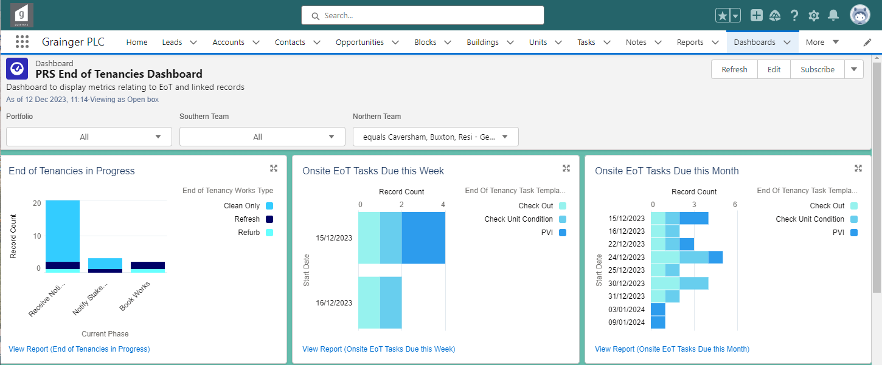
Click on a specific task type or start date to see only those tasks.
See an overview of End of Tenancies that are in progress at your property(-ies).
View the report to see more details & drill down into individual End of Tenancies.

See an overview of Onsite PM tasks that are coming up.
View the report to see more details & drill down into the underlying tasks.

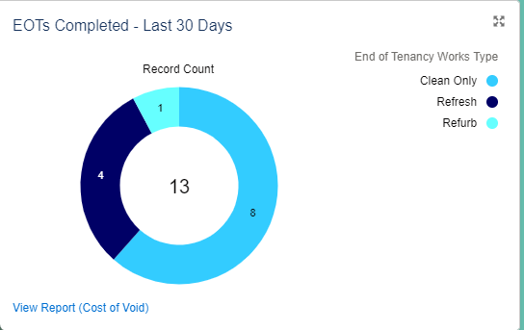
Cost of Void Report
The Cost of Void Report can be accessed from the End of Tenancy dashboards.
This report contains key dates in the EOT process, KPIs as well as the void cost (rent lost) for the time that the unit stood vacant.
Generate the Cost of Void Report

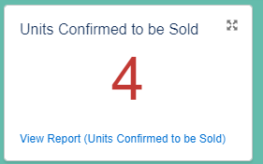
Asset Management Reports
A report of Units Confirmed to be Sold can be accessed from the Asset Management: Portfolio Dashboard.
Access the underlying report

The report displays all units where the notice to quit has already been validated & confirmed with the tenant, the unit has been identified as to be sold, and the End of Tenancy is currently in progess.
The unit’s Available Date is estimated prior to the completion of works.
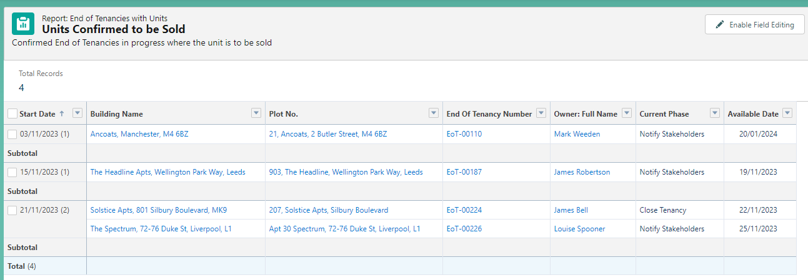

End of Tenancy Owners

Finding My End of Tenancies
All End of Tenancies that are in progress and for which you are the owner, can be found under the End of Tenancies menu item.
Select the ‘My Open End of Tenancies’ list.
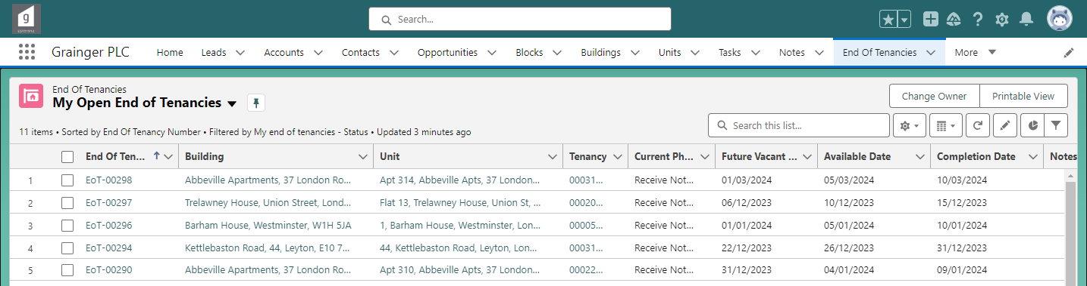

End of Tenancies at Risk
A list of EoTs at Risk, for which you are the owner, can be found on the Salesforce Home page.
This displays all End of Tenancies which have overdue tasks and/or tasks with expected delays.
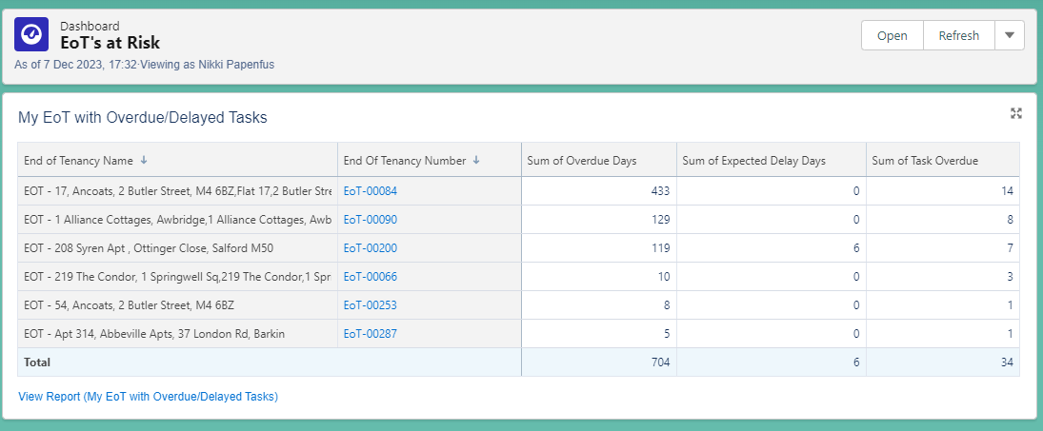
Open the report to see details of all the overdue & delayed tasks.

Approving Requests to Cancel or Close an End of Tenancy
Once the initial Receive Notice phase is complete, the End of Tenancy owner will be required to approve any requests from other users to cancel or close an End of Tenancy that is in progress. See Cancel or Close an End of Tenancy for more detail about this process.
- In addition to receiving email notifications, you can access a list of requests requiring your approval on the Salesforce Home page:
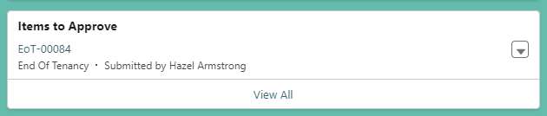
Or select the Approval Requests menu option to access a list of outstanding requests.

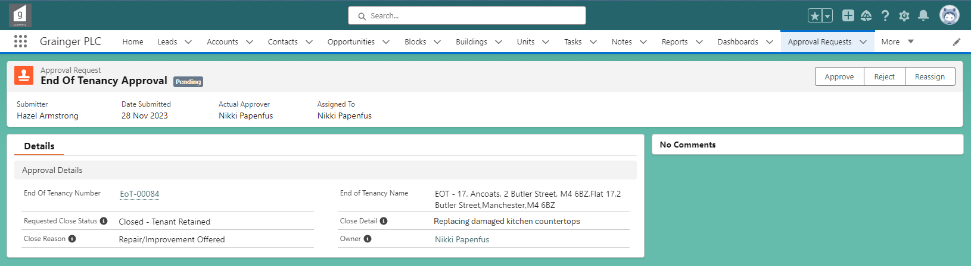
Approve or Reject the request.
- On approving a request, the End of Tenancy will be immediately closed and remaining tasks will no longer appear in team/user task lists.
- On rejecting a request, the End of Tenancy will be set back to active and teams will be able to continue working on the tasks.
- The person who submitted the request will be automatically notified of the approval or rejection.

